SIMATS ENGINEERING

ASSESSMENT TOOL 1

COURSE NAME: OBJECT ORIENTED ANALYSIS AND DESIGN COURSE CODE: CSA1110

COURSE OUTCOME COVERED

CO5: Analyze object-oriented software using quality assurance and usability testing Techniques (BL4,BL5)
Assessment Tool Weightage: 35%

QUESTIONS: 5 Total Marks:35

Annexure A

Constraint-Based Problem Solving

Code of Conduct:
I Bheeshma L / 192511332 certify that this submission is my original work and that I have adhered to the guidelines specified for this assessment.
I understand that any violation of academic integrity rules will result in disciplinary action.

Signature of the student:

BHEESHMA L

RUBRICS FOR CALCULATION:

Constraint-Based Problem Solving Assessment Rubric
Criteria | Weightag e | Level 4 (Exemplary) | Level 3 (Proficient) | Level 2 (Developing) | Level 1 (Beginning)
Problem Understanding | 25% | Clearly defines the problem and identifies all relevant constraints  accurately | Identifies most constraints with minor gaps | Partial understanding; misses key constraints | Fails to identify constraints correctly
Constraint Analysis | 25% | Analyzes constraints effectively and prioritizes them  logically | Provides reasonable analysis with some prioritization | Limited analysis; weak prioritization | No meaningful analysis or prioritization
Solution Development | 25% | Develops optimal and feasible solutions satisfying all  constraints | Develops workable solutions with minor limitations | Solutions partially satisfy constraints | Solutions do not meet constraints
Application of Concepts | 15% | Effectively applies appropriate concepts, methods, or  tools | Applies concepts with minor errors | Limited application; requires guidance | Unable to apply relevant concepts
Justification | 10% | Provides strong justification for decisions with logical  reasoning | Provides justification with some clarity | Weak or unclear justification | No justification provided

Annexure A

Constraint-Based Problem Solving Q1. Scenario: Online Banking System
System Components:
Account Management, Fund Transfer, Bill Payment, Transaction History

Given Constraints:
- Transaction completion time < 2 seconds
- Multi-factor authentication required
- Support 5000+ concurrent users

Question:
Analyze the system using quality assurance techniques under the given constraints. Identify potential defects related to security, performance, and reliability. Propose suitable testing strategies and justify how they ensure system quality. (BL4)

Q2. Scenario: E-Commerce Shopping Application System Features:
Product Search, Shopping Cart, Checkout, Payment Gateway

Usability Constraints:
- Checkout process within 3 steps
- Easy product navigation
- Responsive design for mobile and desktop devices

Question:
Apply usability testing techniques to evaluate the application. Identify usability challenges and recommend design improvements that satisfy the given constraints. Explain how the proposed changes improve customer satisfaction and efficiency. (BL4)

Q3. Scenario: Hospital Management System
Modules:
Patient Registration, Appointment Scheduling, Medical Records, Billing

QA Constraints:
- Patient data accuracy must be maintained
- System availability 24/7
- Simultaneous access by multiple departments

Question:
Use quality assurance practices to analyze the system. Identify critical test cases and discuss how the constraints influence testing priorities, defect prevention, and overall system reliability. (BL5)

Q4. Scenario: Smart Library Management System Features:
Book Search, Book Reservation, Borrow/Return, Notifications

Usability Constraints:
- Search results displayed within 2 seconds
- Accessible interface for all age groups
- Minimal learning curve for first-time users

Question:
Conduct a usability evaluation using appropriate testing methods. Analyze how the given constraints impact interface design and recommend improvements to enhance usability and accessibility. (BL5)

Q5. Scenario: Airline Reservation System Modules:
User Login, Flight Search, Seat Selection, Ticket Booking

QA & Usability Constraints:

- No booking duplication
- System must support peak holiday traffic
- Booking interface should be simple and error-free

Question:
Apply both quality assurance and usability testing techniques under the specified constraints. Identify major risks, propose suitable testing methods, and explain how the system can be optimized for reliability, performance, and user experience. (BL4)

Q1. Online Banking System — Quality Assurance Analysis (BL4)

Scenario: Account Management, Fund Transfer, Bill Payment, Transaction History. Constraints — transaction completion time < 2 seconds, mandatory multi-factor authentication (MFA), and support for 5000+ concurrent users.

Problem Understanding
  - The system must remain fast, secure, and reliable simultaneously — the three constraints often conflict (e.g., strong security checks can add latency, so QA must balance them).
  - Core risk areas: financial data confidentiality, transaction integrity, and system responsiveness under heavy concurrent load.
  - ​

Potential Defects Identified
  - Security defects: weak session management, SQL injection points, OTP/MFA bypass, insufficient encryption of data in transit/at rest.
  - Performance defects: slow database queries, unoptimized API calls causing response time to exceed 2 seconds, memory leaks under sustained load.
  - Reliability defects: transaction duplication or loss during server failure, race conditions in fund transfer, inconsistent state after timeout.

Proposed Testing Strategies
  - Security testing: penetration testing, vulnerability scanning, and authentication/authorization testing to validate MFA at every access point.

  - Performance & load testing: simulate 5000+ concurrent users using tools such as JMeter/LoadRunner to verify the <2 second response-time constraint under peak load.
  - Reliability testing: failover and recovery testing, concurrency/race-condition testing, and database transaction (ACID) testing for fund transfers.
  - Regression testing: ensure new releases/patches do not reintroduce defects in critical modules such as fund transfer and bill payment.

Justification
Security testing directly protects against unauthorized access and data breaches, satisfying the MFA constraint. Load/performance testing validates the sub-2-second response requirement under realistic concurrent usage, while reliability testing (failover, transaction integrity) guarantees consistent behaviour for 5000+ simultaneous users. Together these strategies provide end-to-end assurance that the banking system is secure, fast, and dependable — directly mapping each testing type to a given constraint.
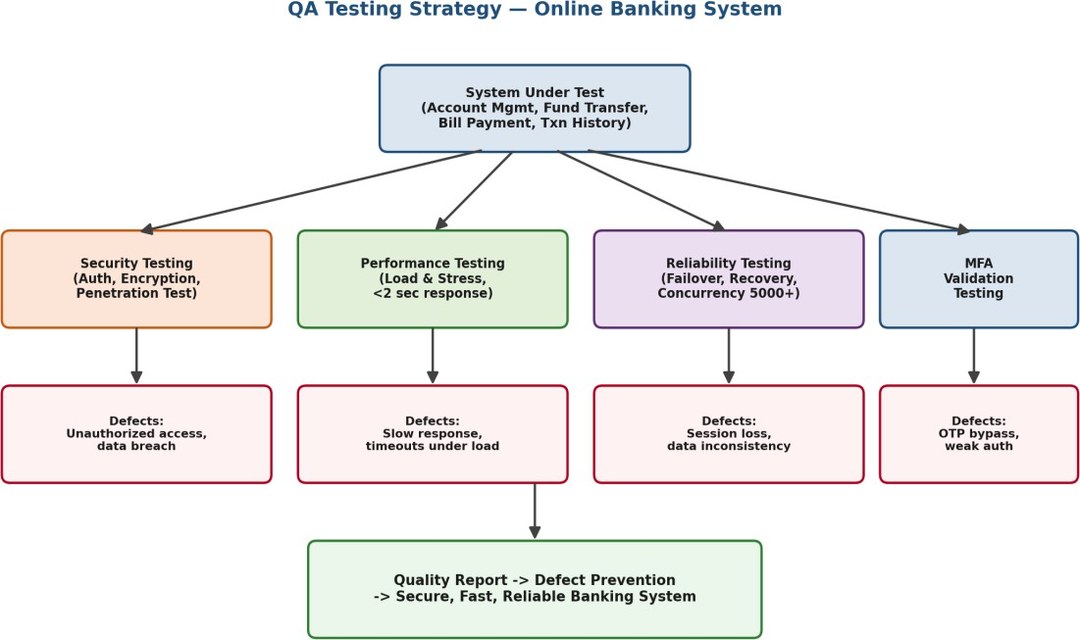

Figure 1: QA testing strategy flow mapped to constraints and defects — Online Banking System

Q2. E-Commerce Shopping Application — Usability Testing (BL4)

Scenario: Product Search, Shopping Cart, Checkout, Payment Gateway. Usability constraints — checkout within 3 steps, easy product navigation, responsive design for mobile and desktop.

Usability Testing Techniques Applied
  - Heuristic evaluation: expert review of the interface against Nielsen's usability heuristics (visibility of status, consistency, error prevention).
  - User task-based testing: real users complete tasks such as 'search a product and complete checkout' while time-on-task and error counts are recorded.
  - A/B testing: compare alternate navigation menus or checkout layouts to identify the more efficient design.
  - Responsive/cross-device testing: validate layout, touch-target size, and readability across mobile, tablet, and desktop breakpoints.

Usability Challenges Identified
  - Checkout process spanning more than 3 steps, causing cart abandonment.
  - Cluttered category/filter navigation making product search slow.
  - Inconsistent layout or overlapping elements on smaller mobile screens.

Recommended Design Improvements
  - Streamlined checkout: consolidate address, shipping, and payment into a single-page or 3-step guided flow with a visible progress indicator.
  - Simplified navigation: faceted search filters, breadcrumb trails, and predictive search suggestions.
  - Responsive UI: mobile-first design using flexible grids so the layout adapts cleanly to any screen size.

Impact on Customer Satisfaction & Efficiency
Reducing checkout to 3 steps lowers cart-abandonment rates and shortens task-completion time, directly increasing conversion. Improved navigation reduces the cognitive load and search time for users, while responsive design ensures a consistent, frustration-free experience regardless of device — collectively improving customer satisfaction, trust, and repeat usage.

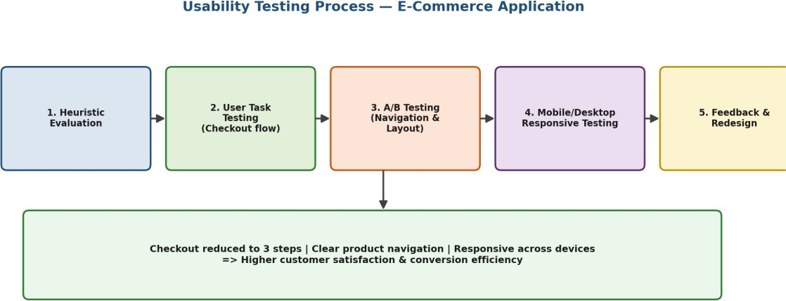

Figure 2: Usability testing process for the e-commerce application

Q3. Hospital Management System — QA Analysis (BL5)

Scenario: Patient Registration, Appointment Scheduling, Medical Records, Billing. QA constraints — patient data accuracy, 24/7 availability, simultaneous multi-department access.

Critical Test Cases
  - Data accuracy tests: verify that patient demographic and medical data entered at registration is validated, stored, and retrieved without corruption.
  - Concurrency tests: verify multiple departments (reception, doctors, billing) can access/update the same patient record simultaneously without conflicts or data loss.
  - Availability/failover tests: verify the system remains operational 24/7, including behaviour during server restarts, backups, or partial outages.
  - Security & audit tests: verify role-based access control so only authorized staff can view/edit sensitive medical records (HIPAA-style compliance).
  - Billing integrity tests: verify charges are calculated correctly and reconciled with treatment/appointment records.
  - ​

Influence of Constraints on Testing Priorities
  - Data accuracy is the highest priority — any defect here directly risks patient safety, so validation and boundary testing on data-entry modules is done first.
  - 24/7 availability elevates the priority of reliability, failover, and disaster-recovery testing over purely cosmetic UI testing.
  - Simultaneous multi-department access requires concurrency and locking-mechanism testing to prevent race conditions and data overwrites.

Defect Prevention & System Reliability
Prioritizing data-accuracy and concurrency test cases early (shift-left testing) prevents critical defects from propagating into production, where they would affect patient care. Continuous availability testing and automated regression suites ensure that new updates do not compromise uptime. Together, this constraint-driven prioritization produces a hospital system that is accurate, always available, and safe for concurrent multi-department use.
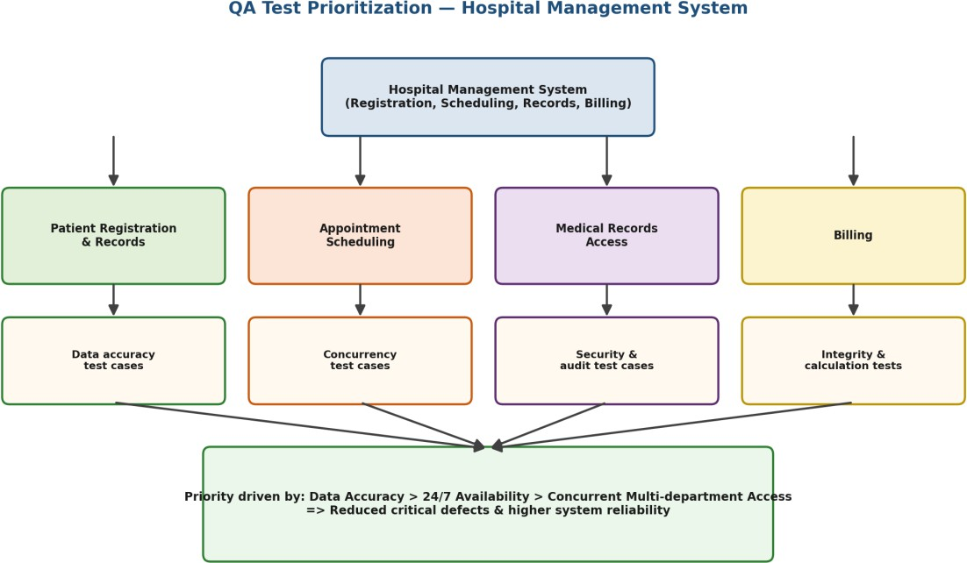

Figure 3: QA test-case prioritization across hospital management modules

Q4. Smart Library Management System — Usability Evaluation (BL5)

Scenario: Book Search, Book Reservation, Borrow/Return, Notifications. Usability constraints — search results within 2 seconds, accessible interface for all age groups, minimal learning curve for first-time users.

Usability Evaluation Methods Used
  - Nielsen's heuristic evaluation: experts assess the interface against usability heuristics such as visibility of system status and error prevention.
  - Think-aloud protocol testing: representative users (students, staff, senior members) verbalize their thoughts while performing search/borrow tasks, exposing confusion points.
  - System Usability Scale (SUS) survey: a standardized questionnaire quantifies overall perceived usability after task completion.
  - Accessibility testing (WCAG guidelines): checks font size, color contrast, keyboard navigation, and screen-reader compatibility for all age groups.
  - ​

Impact of Constraints on Interface Design
  - The 2-second search constraint requires a lightweight, indexed search UI with instant-feedback loading indicators.
  - Accessibility for all age groups requires larger fonts, high-contrast themes, and simple iconography rather than text-heavy menus.
  - A minimal learning curve requires a guided/first-time onboarding tour and consistent, predictable navigation patterns.
  - ​

Recommended Improvements
  - Performance: cache frequent search queries and use asynchronous loading so results consistently render under 2 seconds.
  - Accessibility: adjustable font sizes, voice-assisted search, and simplified iconography for older or less tech-savvy users.
  - Onboarding: a short interactive walkthrough and contextual tooltips to reduce the learning curve for first-time users.

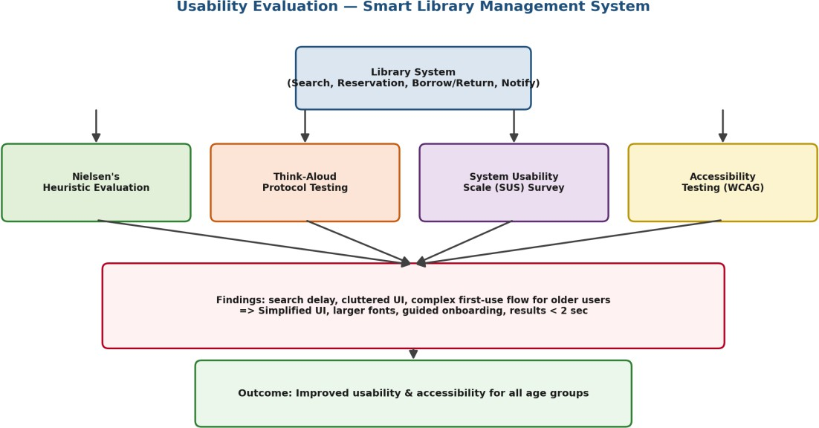
Figure 4: Usability evaluation methods and resulting design improvements

Q5. Airline Reservation System — Combined QA & Usability Testing (BL4)

Scenario: User Login, Flight Search, Seat Selection, Ticket Booking. Constraints
— no booking duplication, support for peak holiday traffic, and a simple, error-free booking interface.

Major Risks Identified
  - Double booking / duplicate seat allocation caused by concurrent requests for the same seat.
  - System slowdown or crash during peak holiday traffic spikes.
  - Confusing or error-prone booking interface leading to incorrect flight/seat selection.

Proposed Testing Methods
  - Concurrency & transaction-locking testing: ensures seat-booking transactions are atomic and idempotent so two users cannot book the same seat simultaneously.
  - Load & stress testing: simulates peak holiday traffic (surge in concurrent searches/bookings) to validate auto-scaling and response-time stability.

  - Usability/error-prevention testing: task-based user testing and heuristic review of the booking flow to minimise input errors, with confirmation dialogs before final booking.
  - Regression & end-to-end testing: validates that login, search, seat selection, and booking work correctly together after each release.

Optimization for Reliability, Performance & User Experience
Implementing idempotent, database-locked booking transactions eliminates duplicate bookings even under high concurrency. Auto-scaling infrastructure combined with load testing ensures the system sustains peak holiday demand without downtime. Simplifying the booking interface — with clear steps, inline validation, and confirmation screens — reduces user error and builds confidence. Together, QA and usability testing ensure the airline system is reliable, performant, and easy to use even under maximum load.
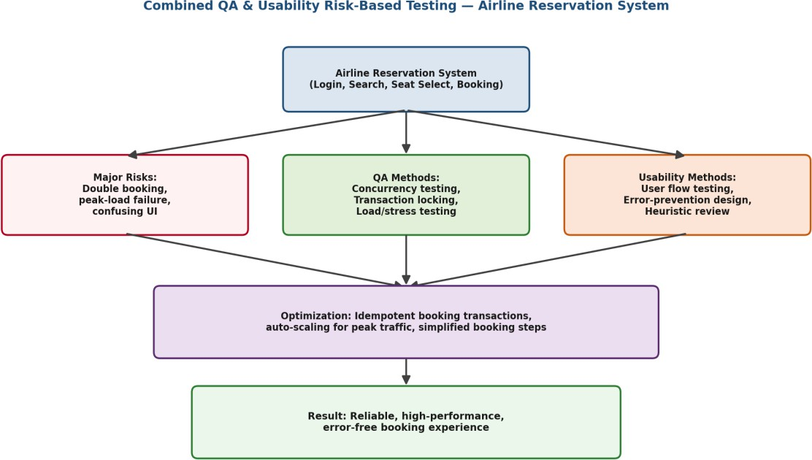

Figure 5: Combined QA and usability risk-based testing approach — Airline Reservation System

